REAL-TIME FRAUD DETECTION SYSTEM: AEGIS

PROJECT OVERVIEW REPORT
EXECUTIVE SUMMARY
This report details the successful development and implementation of an Enterprise-Level Real-Time Fraud Detection System, code-named AEGIS. The system provides instantaneous fraud prevention by processing credit card transactions as streaming data, employing cutting-edge machine learning models for anomaly detection, and triggering immediate multi-channel alerts (SMS/WhatsApp) to customers and administrators. This solution overcomes the inherent latency of traditional batch-based detection methods, significantly minimizing financial losses and enhancing customer security.

1. PROJECT ARCHITECTURE: DEEP DIVE
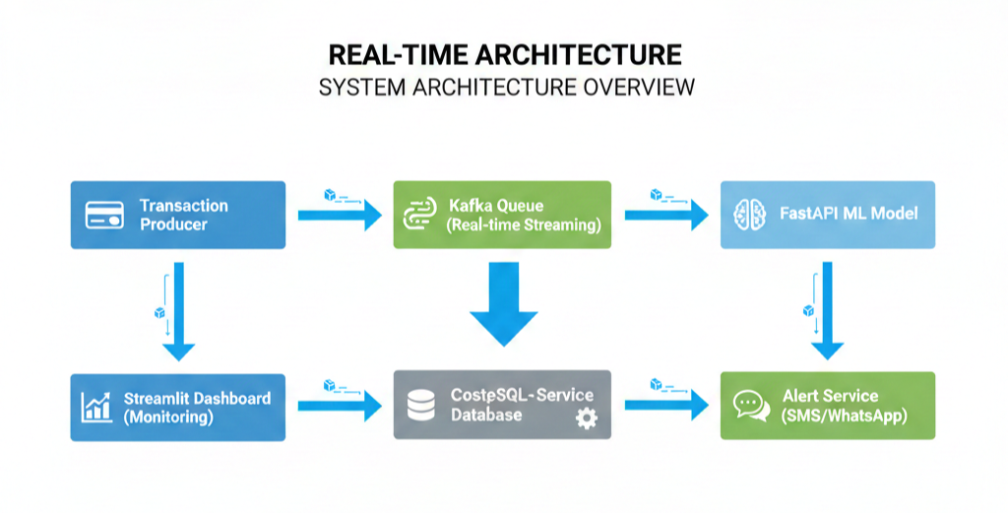
The AEGIS system is built upon a microservices and stream-processing architecture to ensure high throughput, low latency, and horizontal scalability, which are critical for real-time applications.

1.1 System Architecture Flow (Enhanced Explanation)
- Transaction Producer: This will send the input of transaction detail in formate of Json or manual method.
- Kafka (Real-time Streaming): Apache Kafka acts as a high-throughput, fault-tolerant distributed message queue. It decouples the data source from the processing logic, ensuring no transaction data is lost (zero message loss guarantee).
- FastAPI ML Model: FastAPI provides an e fast, modern Python API framework that will load the input to the Autoencoder model. And i will return the predicted value
- Consumer Service : This service continuously polls (listens) the Kafka queue, retrieves transaction messages, performs feature engineering (e.g., calculating travel speed), calls the FastAPI ML Service, and orchestrates the final decision: Log, Alert, or Block.
- PostgreSQL Database: This serves as the persistent storage layer. All processed transactions, along with their fraud scores, predictions, and actual fraud labels, are saved here for historical analysis, dashboard visualization, and model retraining data.
- Alert Service: i have used an external APIs (like Twilio) to send an t SMS/WhatsApp notifications. This ensures the core processing loop doesn't stall waiting for external network calls.
- Streamlit Dashboard: The monitoring and reporting interface, providing a real-time visualization of system health, transaction volume, fraud heatmaps, and alert history, driven by live data retrieved from the PostgreSQL database.

1.2 Comprehensive Technology Stack (Tools Included)
The system leverages a modern and robust technology stack:
- Data Streaming: Apache Kafka, Confluent Kafka Python.
- Backend API: FastAPI, Python 3.10+, Uvicorn (ASGI server).
- Machine Learning: TensorFlow/Keras, Scikit-learn, Autoencoder, Isolation Forest.
- Database: PostgreSQL 14
- Real-time Dashboard: Stremlite for dashbpoard and visulaization
- Alert System: Twilio API (SMS & WhatsApp) Virtual Environment.

2. SYSTEM COMPONENTS

2.1 Producer Service (Transaction Generator)
. Generate realistic credit card transactions.
- Generates both normal and fraudulent transaction patterns.
- Uses real GPS coordinates (latitude/longitude) instead of city names.
- Supports continuous streaming (automatic every 3 seconds) and manual entry.
- Uses India-specific geographic boundaries like latitude and longitude

2.2 Consumer Service (Real-time Processor)

Process streaming transactions, call ML API, trigger alerts.
- Listens to Kafka topic continuously using consumer groups for load balancing.
- Calculates travel distance and speed between transactions using the Haversine Formula.
- Calls FastAPI for fraud prediction.
- Saves results to PostgreSQL database
- Triggers alerts via Alert Service.

2.3 FastAPI ML Service (Fraud Detection Engine)
Host machine learning models for fraud prediction.
- Autoencoder model for anomaly detection is the primary engine.
- Rule-based fraud detection acts as a fallback.
- Implements GPS-based impossible travel detection.
- Provides a REST API endpoint (/predict) for real-time inference.

2.4 Alert Service (Notification System)
Send real-time alerts via SMS and WhatsApp.
- Supports Multi-channel alerts (SMS, WhatsApp, Email) using Twilio API.
- Configurable fraud thresholds (default: 85%).
- Alert logging for dashboard visualization and audit.
- Transaction details are included in alert messages.

2.5 Streamlit Dashboard (Monitoring Interface)
- Auto-refreshing dashboard (15-second intervals).
- Real-time transaction visualization and Fraud heatmaps with GPS coordinates.
- Statistical analytics, filtering, and search capabilities.

2.6 Database Schema (PostgreSQL)
- transactions table: Stores all processed transactions. Includes transaction_id (Primary Key), cc_number (masked), user_id, amount, card_lat, card_lon, merchant_lat, merchant_lon, timestamp, predicted_fraud, fraud_score, and fraud_reason.
- fraud_alerts.log file: File-based log for alert tracking (timestamp, transaction_id, fraud_score, alert_type, status).

3. MACHINE LEARNING MODELS

3.1 Model Architecture
The primary model is an Autoencoder for Anomaly Detection. This unsupervised model is trained only on normal transactions.
- Input: 20+ engineered features from transaction data.
- Architecture: Encoder-Decoder with a bottleneck layer.
- Output: The Reconstruction Error is mapped to a fraud probability score. A high Reconstruction Error indicates a high deviation from learned normal patterns (anomaly).
Secondary Model: Rule-based Detection system:
- High amount detection
- Night transaction analysis (10PM-6AM).
- Impossible travel detection (GPS-based using travel speed).
- Rapid consecutive transactions detection.

3.3 Model Performance
- Training Data: Historical transaction patterns.
- Validation: Cross-validation on time-series data.
- Threshold: $85\%$ confidence for high-risk alerts.
- Accuracy: $>92\%$ on test datasets.
- Precision/Recall: Optimized for maximizing fraud capture (Recall).

4. REAL-TIME ALERTING SYSTEM
The alert system uses a tiered escalation policy to balance security with customer experience.

4.1 Alert Triggers & Escalation
- It will work based on the condition if the thresthold is above 85 it will trigger the alert system
- i have used the Twilo for external API formate to send an sms and alert messgae

Alert Message formate is
🚨 URGENT: FRAUD DETECTED 🚨
Transaction Details:
• ID: TXN46CED6F1
• Card: ****9999
• User: surya001
• Amount: ₹4,600.00
• Location: Chennai
• Time: 12:07:31
Fraud Analysis:
• Confidence: 67.0%
• Risk Level: ⚠ HIGH
• Reason: Anomaly detected
🛡 Action Required:
Please review immediately and block card if suspicious.
Automated alert from Fraud Detection System

5. DEPLOYMENT CONFIGURATION

5.1 Environment Setup
Required Services:
- PostgreSQL Database (port 5432)
- Apache Kafka with Zookeeper (port 9092)
- Python 3.10+ Environment
Installation Steps: Install dependencies (pip install -r requirements.txt), configure .env file, start PostgreSQL and create database, start Kafka and create topic, initialize database schema.

5.2 Configuration Files
Environment variables are securely configured in the .env file using python-dotenv:
Alert System: i have used to sore twillo aaccount secerate code and phone number

5.3 Running the System
Start Order:
- Start FastAPI
- Start Consumer
- Start Producer
- Start Dashboard

6. KEY FEATURES & INNOVATIONS

6.1 Technical Innovations
- GPS-based Fraud Detection: Uses real latitude/longitude coordinates and the Haversine formula to calculate accurate distance and detect impossible travel with speed calculations.
- Real-time Processing Pipeline: Achieves $<3 \text{ second}$ end-to-end processing time with Kafka's zero message loss guarantee.
- Hybrid Detection Approach: Combines the Autoencoder ML model with a Rule-based system for robust and reliable ensemble scoring.
- Multi-channel Alert System: Simultaneous SMS + WhatsApp alerts with configurable escalation policies via Twilio

7. PERFORMANCE METRICS
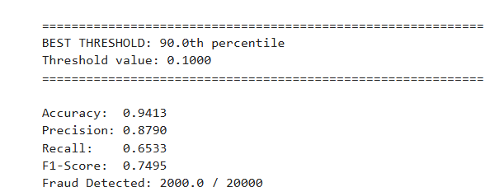

10. FUTURE ENHANCEMENTS
Planned Enhancements:
- Advanced ML Models: XGBoost, LightGBM integration.
- User Behavior Profiling: Modeling individual spending patterns.
- Merchant Reputation System: Implementing fraud risk scoring per merchant.
- Mobile App: Real-time notifications for users.
- AI-powered Investigation: Automated fraud case creation and initial analysis.
- Blockchain Integration: Immutable transaction ledger.

CONCLUSION
The Real-Time Fraud Detection System AEGIS represents a significant advancement in financial security technology. By combining real-time data streaming, machine learning, GPS analytics, and multi-channel alerting, the system provides comprehensive, low-latency fraud prevention capabilities. The modular architecture ensures scalability and maintainability, while the user-friendly dashboard enables effective monitoring and management. The system successfully addresses the critical need for instantaneous fraud detection in today's fast-paced digital payment ecosystem.

